SURVEY INSTRUCTIONS

Once you have completed the survey, you will need to save it to your desktop.
- Under File at the top left of your screen, scroll down to SAVE AS and click PDF.

- A box will pop up. In the white text box, name your survey COMPLETED SURVEY.

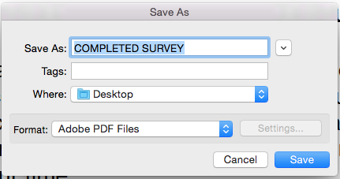

- Under the WHERE drop-down menu, scroll down to DESKTOP.
- An icon will appear on your DESKTOP. It will look like this:

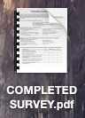

- Open a NEW MESSAGE in your email software, and drag COMPLETED SURVEY onto it. This will attach it to the email message.

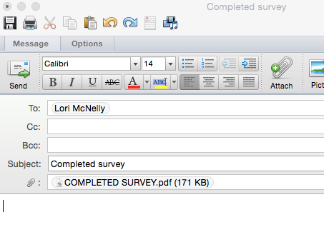
- SEND to SCBDD Community Relations Coordinator Lori McNelly at lmcnelly@sciotodd.org

